- In the “Add Charge” page of – when user selects “Consultation” type – it Should show the “Admitting Doctor” option as well
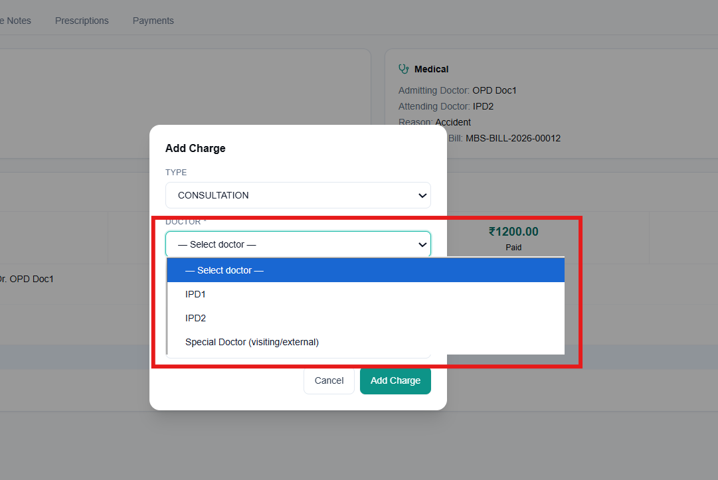
- The Fees set for IPD doctor from Doctor’s Page – is showing as OPD consultation in the admin settings page. This consultation fee should be linked with the doctor type – OPD/IPD/Emergency. For IPD doctor – there should only be IPD fees, similarly for a doctor who attends both OPD and Emergency – the respective consultation fee for OPD and emergency should be tagged correctly and it should reflect in billing as well. For example if a receptionist has selected “Emergency Type” from the Generate Bill page and selects a doctor who has both OPD and Emergency – only the Emergency consultation fee should get auto-populated
- Similarly for “Add Charge” page for nurses – If a nurse selects an IPD doctor in the “Add Charge” page – the doctor’s fees should auto-populate. Please note as per point 1 – a nurse can also add charges for OPD/Emergency/Admitting doctor for an ongoing IPD bill – the selected doctor’s respective consulation fee should be added.

